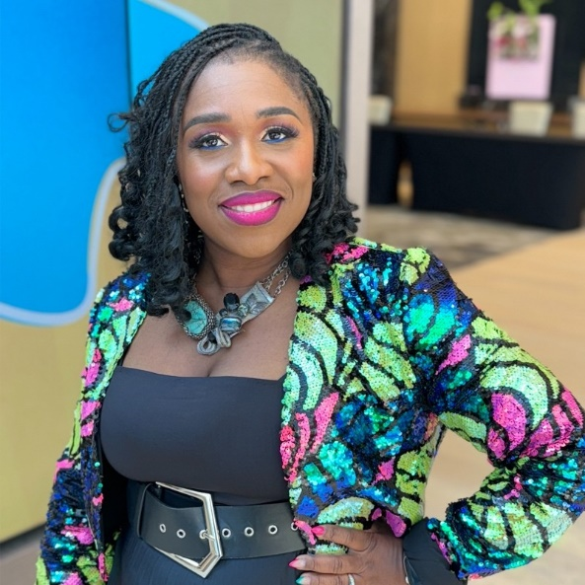Many event professionals who are tasked with hiring speakers, managing vendors, meeting food and beverage minimums often overlook or underestimate how to capture and keep the attention of a in-person or virtual audience. This leaves audience members disengaged, bored and not connected to your conference. As a result, attendees are NOT returning to your event, sponsorship support decreases and poor event reviews become popular.   
  
This is why a professional event Emcee is the glue that holds your event together ensuring your audience is activated, connected and captivated from start to finish NOT just for a 60 minute keynote or 45 minute breakout session.   
  
Consider me your go-to emcee expert!   
  
I transform events from good to GRAND for 1 or multiple days so attendees and sponsors rave, return and refer others to attend your conference in the future.   
  
With high energy, interactive engagement, and unmatched expertise, I don't just host events, I activate your audience.   
  
As a professional conference emcee my goal is to:   
-Ensure attendees are inspired, connected, and motivated during the entire event experience.   
  
-Be the glue that holds your conference together by creating unforgettable experiences that leave attendees raving, sponsors returning, and speakers rejoicing.   
  
I have over 19 years of in-person speaking and event hosting experience, 2 degrees in the communication field and I've authored 2 books. I also has have racked up over 185 Speaker/Emcee recommendations on Linked In.   
  
I boldly believe events can go from mediocre to mind-blowing with a trusted and professional event partner that is committed to transforming your event into an EPIC experience.